AD3002 -HEALTH CARE ANALYTICS
Assignment- 2

Clinical Prediction Models-Heart Disease Predicting
import numpy as np
import pandas as pd
import matplotlib.pyplot as plt
import seaborn as sns
from scipy.stats import shapiro
from sklearn.datasets import make_classification
from sklearn.pipeline import make_pipeline
import tensorflow as tf
from sklearn.preprocessing import StandardScaler
from sklearn.model_selection import train_test_split
from sklearn.linear_model import LogisticRegression
from sklearn.metrics import accuracy_score
from sklearn.metrics import confusion_matrix
from sklearn.metrics import classification_report
from yellowbrick.classifier import ClassPredictionError
from google.colab import drive
drive.mount('/content/drive')
Mounted at /content/drive
import os
for dirname, _, filenames in os.walk('/content/drive/MyDrive/Heart_Disease_Prediction.csv'):
for filename in filenames:
print(os.path.join(dirname, filename))
health_data = pd.read_csv('/content/drive/MyDrive/Heart_Disease_Prediction.csv')
health_data.shape
(270, 15)
health_data.info()
<class 'pandas.core.frame.DataFrame'>
RangeIndex: 270 entries, 0 to 269
Data columns (total 15 columns):
# Column Non-Null Count Dtype
--- ------ -------------- -----
0 index 270 non-null int64
1 Age 270 non-null int64
2 Sex 270 non-null int64
3 Chest pain type 270 non-null int64
4 BP 270 non-null int64
5 Cholesterol 270 non-null int64
6 FBS over 120 270 non-null int64
7 EKG results 270 non-null int64
8 Max HR 270 non-null int64
9 Exercise angina 270 non-null int64
10 ST depression 270 non-null float64
11 Slope of ST 270 non-null int64
12 Number of vessels fluro 270 non-null int64
13 Thallium 270 non-null int64
14 Heart Disease 270 non-null object
dtypes: float64(1), int64(13), object(1)
memory usage: 31.8+ KB
health_data.head()
index Age Sex Chest pain type BP Cholesterol FBS over 120 \
0 0 70 1 4 130 322 0
1 1 67 0 3 115 564 0
2 2 57 1 2 124 261 0
3 3 64 1 4 128 263 0
4 4 74 0 2 120 269 0
EKG results Max HR Exercise angina ST depression Slope of ST \
0 2 109 0 2.4 2
1 2 160 0 1.6 2
2 0 141 0 0.3 1
3 0 105 1 0.2 2
4 2 121 1 0.2 1
Number of vessels fluro Thallium Heart Disease
0 3 3 Presence
1 0 7 Absence
2 0 7 Presence
3 1 7 Absence
4 1 3 Absence
health_data['Heart Disease']=health_data['Heart Disease'].replace({'Presence':1, 'Absence':0})
print(health_data)
index Age Sex Chest pain type BP Cholesterol FBS over 120 \
0 0 70 1 4 130 322 0
1 1 67 0 3 115 564 0
2 2 57 1 2 124 261 0
3 3 64 1 4 128 263 0
4 4 74 0 2 120 269 0
.. ... ... ... ... ... ... ...
265 265 52 1 3 172 199 1
266 266 44 1 2 120 263 0
267 267 56 0 2 140 294 0
268 268 57 1 4 140 192 0
269 269 67 1 4 160 286 0
EKG results Max HR Exercise angina ST depression Slope of ST \
0 2 109 0 2.4 2
1 2 160 0 1.6 2
2 0 141 0 0.3 1
3 0 105 1 0.2 2
4 2 121 1 0.2 1
.. ... ... ... ... ...
265 0 162 0 0.5 1
266 0 173 0 0.0 1
267 2 153 0 1.3 2
268 0 148 0 0.4 2
269 2 108 1 1.5 2
Number of vessels fluro Thallium Heart Disease
0 3 3 1
1 0 7 0
2 0 7 1
3 1 7 0
4 1 3 0
.. ... ... ...
265 0 7 0
266 0 7 0
267 0 3 0
268 0 6 0
269 3 3 1
[270 rows x 15 columns]
health_data.info()
<class 'pandas.core.frame.DataFrame'>
RangeIndex: 270 entries, 0 to 269
Data columns (total 15 columns):
# Column Non-Null Count Dtype
--- ------ -------------- -----
0 index 270 non-null int64
1 Age 270 non-null int64
2 Sex 270 non-null int64
3 Chest pain type 270 non-null int64
4 BP 270 non-null int64
5 Cholesterol 270 non-null int64
6 FBS over 120 270 non-null int64
7 EKG results 270 non-null int64
8 Max HR 270 non-null int64
9 Exercise angina 270 non-null int64
10 ST depression 270 non-null float64
11 Slope of ST 270 non-null int64
12 Number of vessels fluro 270 non-null int64
13 Thallium 270 non-null int64
14 Heart Disease 270 non-null int64
dtypes: float64(1), int64(14)
memory usage: 31.8 KB
health_data.describe()
index Age Sex Chest pain type BP \
count 270.000000 270.000000 270.000000 270.000000 270.000000
mean 134.500000 54.433333 0.677778 3.174074 131.344444
std 78.086491 9.109067 0.468195 0.950090 17.861608
min 0.000000 29.000000 0.000000 1.000000 94.000000
25% 67.250000 48.000000 0.000000 3.000000 120.000000
50% 134.500000 55.000000 1.000000 3.000000 130.000000
75% 201.750000 61.000000 1.000000 4.000000 140.000000
max 269.000000 77.000000 1.000000 4.000000 200.000000
Cholesterol FBS over 120 EKG results Max HR Exercise angina \
count 270.000000 270.000000 270.000000 270.000000 270.000000
mean 249.659259 0.148148 1.022222 149.677778 0.329630
std 51.686237 0.355906 0.997891 23.165717 0.470952
min 126.000000 0.000000 0.000000 71.000000 0.000000
25% 213.000000 0.000000 0.000000 133.000000 0.000000
50% 245.000000 0.000000 2.000000 153.500000 0.000000
75% 280.000000 0.000000 2.000000 166.000000 1.000000
max 564.000000 1.000000 2.000000 202.000000 1.000000
ST depression Slope of ST Number of vessels fluro Thallium \
count 270.00000 270.000000 270.000000 270.000000
mean 1.05000 1.585185 0.670370 4.696296
std 1.14521 0.614390 0.943896 1.940659
min 0.00000 1.000000 0.000000 3.000000
25% 0.00000 1.000000 0.000000 3.000000
50% 0.80000 2.000000 0.000000 3.000000
75% 1.60000 2.000000 1.000000 7.000000
max 6.20000 3.000000 3.000000 7.000000
Heart Disease
count 270.000000
mean 0.444444
std 0.497827
min 0.000000
25% 0.000000
50% 0.000000
75% 1.000000
max 1.000000
health_data = health_data.drop('index', axis=1)
health_data.info()
<class 'pandas.core.frame.DataFrame'>
RangeIndex: 270 entries, 0 to 269
Data columns (total 14 columns):
# Column Non-Null Count Dtype
--- ------ -------------- -----
0 Age 270 non-null int64
1 Sex 270 non-null int64
2 Chest pain type 270 non-null int64
3 BP 270 non-null int64
4 Cholesterol 270 non-null int64
5 FBS over 120 270 non-null int64
6 EKG results 270 non-null int64
7 Max HR 270 non-null int64
8 Exercise angina 270 non-null int64
9 ST depression 270 non-null float64
10 Slope of ST 270 non-null int64
11 Number of vessels fluro 270 non-null int64
12 Thallium 270 non-null int64
13 Heart Disease 270 non-null int64
dtypes: float64(1), int64(13)
memory usage: 29.7 KB
features_variables = health_data.iloc[:, 0:13]
#get the outcome variables
outcome_variable = health_data.iloc[:, -1]
features_variables.head()
Age Sex Chest pain type BP Cholesterol FBS over 120 EKG results \
0 70 1 4 130 322 0 2
1 67 0 3 115 564 0 2
2 57 1 2 124 261 0 0
3 64 1 4 128 263 0 0
4 74 0 2 120 269 0 2
Max HR Exercise angina ST depression Slope of ST \
0 109 0 2.4 2
1 160 0 1.6 2
2 141 0 0.3 1
3 105 1 0.2 2
4 121 1 0.2 1
Number of vessels fluro Thallium
0 3 3
1 0 7
2 0 7
3 1 7
4 1 3
#plot the variables to check for outliers
fig, axs = plt.subplots(nrows=5, ncols=3, figsize=(5,30))
# Flatten the axs array to simplify indexing
axs = axs.flatten()
for i, feature in enumerate(features_variables.columns):
axs[i].boxplot(features_variables[feature])
axs[i].set_title(feature)
# Remove any unused subplots
for j in range(len(features_variables.columns), len(axs)):
fig.delaxes(axs[j])
# Display the plot
plt.show()
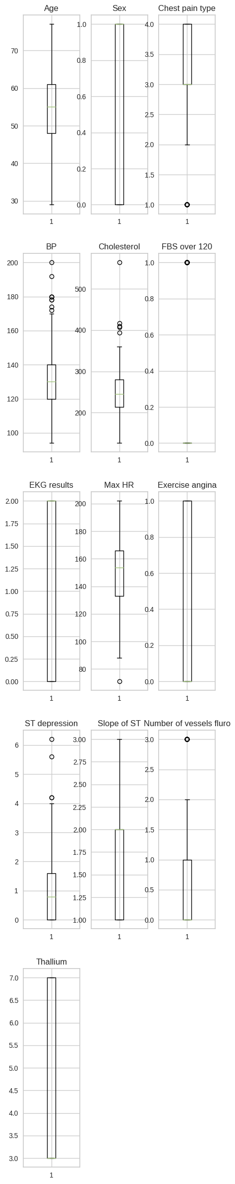
hist_variables = health_data.iloc[:,[0,3,4,7,9]]
fig, axs = plt.subplots(nrows=5, ncols=3, figsize=(20, 20))
# Flatten the axs array to simplify indexing
axs = axs.flatten()
for i, feature in enumerate(hist_variables.columns):
axs[i].hist(hist_variables[feature])
axs[i].set_title(feature)
axs[i].set_xlabel('Values')
# Remove any unused subplots
for j in range(len(hist_variables.columns), len(axs)):
fig.delaxes(axs[j])
# Adjust spacing between subplots
fig.tight_layout()
# Display the plot
plt.show()
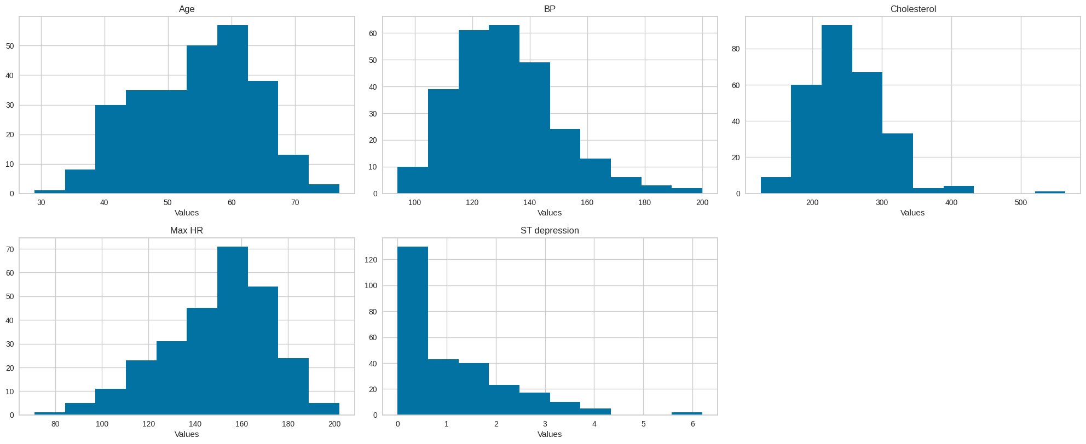
alpha = 0.05 #set significance level
for column in hist_variables.columns:
column_data = hist_variables[column]
statistic, p_value = shapiro(column_data)
#print the test result for the current column
print("Column:", column)
print("Statistic:", statistic)
print("p_value:", p_value)
#check for normality per column
if (p_value < alpha):
print("The data does not follow normal distribution")
else:
print("The data follows normal distribution")
print()
Column: Age
Statistic: 0.9882946610450745
p_value: 0.02765394188463688
The data does not follow normal distribution
Column: BP
Statistic: 0.9649232625961304
p_value: 3.7402976431621937e-06
The data does not follow normal distribution
Column: Cholesterol
Statistic: 0.9433528780937195
p_value: 1.0786085802294565e-08
The data does not follow normal distribution
Column: Max HR
Statistic: 0.9756816625595093
p_value: 0.00014500865654554218
The data does not follow normal distribution
Column: ST depression
Statistic: 0.8515622615814209
p_value: 2.102865382435444e-15
The data does not follow normal distribution
sns.countplot(x = outcome_variable, data = health_data, palette=['yellow', 'red'])
<Axes: xlabel='Heart Disease', ylabel='count'>
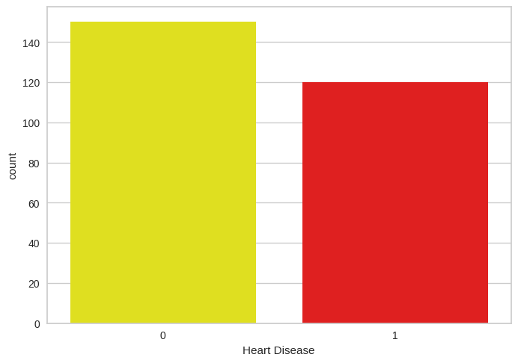
noncat_variables = health_data.iloc[:,[1,2,5,6,8,10,11,12]]
noncat_variables
Sex Chest pain type FBS over 120 EKG results Exercise angina \
0 1 4 0 2 0
1 0 3 0 2 0
2 1 2 0 0 0
3 1 4 0 0 1
4 0 2 0 2 1
.. ... ... ... ... ...
265 1 3 1 0 0
266 1 2 0 0 0
267 0 2 0 2 0
268 1 4 0 0 0
269 1 4 0 2 1
Slope of ST Number of vessels fluro Thallium
0 2 3 3
1 2 0 7
2 1 0 7
3 2 1 7
4 1 1 3
.. ... ... ...
265 1 0 7
266 1 0 7
267 2 0 3
268 2 0 6
269 2 3 3
[270 rows x 8 columns]
num_columns = len(noncat_variables.columns)
num_rows = (num_columns // 2) + (num_columns % 2)
fig, axes = plt.subplots(nrows=num_rows, ncols=2, figsize=(12, num_rows * 4))
# Iterate over the columns and plot count plots
for i, column in enumerate(noncat_variables.columns):
row = i // 2
col = i % 2
sns.countplot(x=column, data=health_data, ax=axes[row, col])
axes[row, col].set_title(f'Count Plot - {column}')
# Remove any empty subplots
if num_columns % 2 != 0:
fig.delaxes(axes[num_rows-1, 1])
# Adjust subplot spacing
plt.tight_layout()
# Display the plot
plt.show()
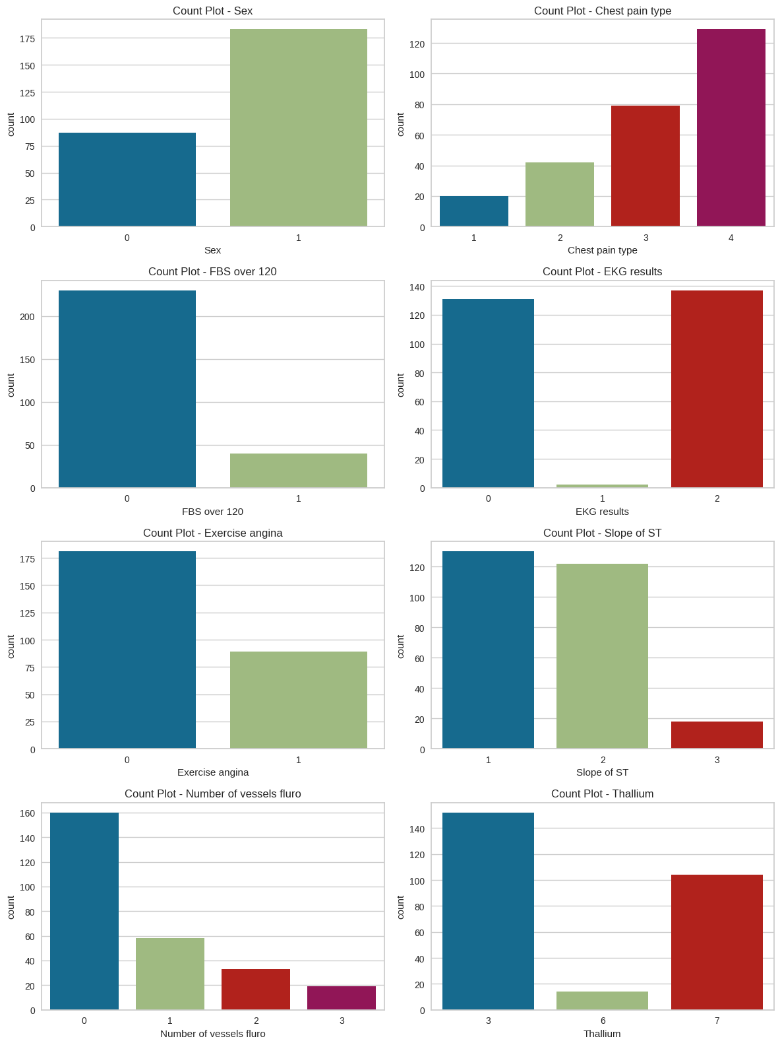
X = health_data.iloc[:, :-1] # Select all columns except the last one
y = health_data.iloc[:, -1]
# Split the data into training and testing sets
X_train, X_test, y_train, y_test = train_test_split(X, y, test_size=0.2, random_state=42)
# Standardize the features (optional but recommended for deep learning)
scaler = StandardScaler()
X_train = scaler.fit_transform(X_train)
X_test = scaler.transform(X_test)
# Create a deep learning model using TensorFlow and Keras
model = tf.keras.Sequential([
tf.keras.layers.Dense(128, activation='relu', input_shape=(X_train.shape[1],)),
tf.keras.layers.Dense(64, activation='relu'),
tf.keras.layers.Dense(1, activation='sigmoid')
])
# Compile the model
model.compile(optimizer='adam', loss='binary_crossentropy', metrics=['accuracy'])
# Train the model
model.fit(X_train, y_train, epochs=50, batch_size=32, validation_data=(X_test, y_test))
# Evaluate the model
test_loss, test_accuracy = model.evaluate(X_test, y_test)
print(f"Test Accuracy: {test_accuracy}")
Epoch 1/50
7/7 [==============================] - 3s 82ms/step - loss: 0.6791 - accuracy: 0.5556 - val_loss: 0.5894 - val_accuracy: 0.8148
Epoch 2/50
7/7 [==============================] - 0s 17ms/step - loss: 0.5533 - accuracy: 0.7685 - val_loss: 0.5058 - val_accuracy: 0.8704
Epoch 3/50
7/7 [==============================] - 0s 24ms/step - loss: 0.4690 - accuracy: 0.8148 - val_loss: 0.4458 - val_accuracy: 0.8519
Epoch 4/50
7/7 [==============================] - 0s 15ms/step - loss: 0.4132 - accuracy: 0.8333 - val_loss: 0.4037 - val_accuracy: 0.8519
Epoch 5/50
7/7 [==============================] - 0s 14ms/step - loss: 0.3802 - accuracy: 0.8426 - val_loss: 0.3753 - val_accuracy: 0.8519
Epoch 6/50
7/7 [==============================] - 0s 18ms/step - loss: 0.3527 - accuracy: 0.8611 - val_loss: 0.3587 - val_accuracy: 0.8519
Epoch 7/50
7/7 [==============================] - 0s 15ms/step - loss: 0.3369 - accuracy: 0.8704 - val_loss: 0.3492 - val_accuracy: 0.8519
Epoch 8/50
7/7 [==============================] - 0s 17ms/step - loss: 0.3232 - accuracy: 0.8704 - val_loss: 0.3425 - val_accuracy: 0.8519
Epoch 9/50
7/7 [==============================] - 0s 21ms/step - loss: 0.3122 - accuracy: 0.8750 - val_loss: 0.3400 - val_accuracy: 0.8519
Epoch 10/50
7/7 [==============================] - 0s 44ms/step - loss: 0.3011 - accuracy: 0.8750 - val_loss: 0.3390 - val_accuracy: 0.8333
Epoch 11/50
7/7 [==============================] - 0s 48ms/step - loss: 0.2921 - accuracy: 0.8750 - val_loss: 0.3392 - val_accuracy: 0.8704
Epoch 12/50
7/7 [==============================] - 0s 30ms/step - loss: 0.2830 - accuracy: 0.8750 - val_loss: 0.3427 - val_accuracy: 0.8704
Epoch 13/50
7/7 [==============================] - 0s 18ms/step - loss: 0.2759 - accuracy: 0.8843 - val_loss: 0.3383 - val_accuracy: 0.8519
Epoch 14/50
7/7 [==============================] - 0s 8ms/step - loss: 0.2670 - accuracy: 0.8935 - val_loss: 0.3461 - val_accuracy: 0.8704
Epoch 15/50
7/7 [==============================] - 0s 10ms/step - loss: 0.2579 - accuracy: 0.8889 - val_loss: 0.3420 - val_accuracy: 0.8889
Epoch 16/50
7/7 [==============================] - 0s 11ms/step - loss: 0.2495 - accuracy: 0.8981 - val_loss: 0.3453 - val_accuracy: 0.8704
Epoch 17/50
7/7 [==============================] - 0s 8ms/step - loss: 0.2416 - accuracy: 0.9028 - val_loss: 0.3488 - val_accuracy: 0.8704
Epoch 18/50
7/7 [==============================] - 0s 8ms/step - loss: 0.2333 - accuracy: 0.9028 - val_loss: 0.3501 - val_accuracy: 0.8704
Epoch 19/50
7/7 [==============================] - 0s 9ms/step - loss: 0.2262 - accuracy: 0.9120 - val_loss: 0.3524 - val_accuracy: 0.8889
Epoch 20/50
7/7 [==============================] - 0s 7ms/step - loss: 0.2200 - accuracy: 0.9074 - val_loss: 0.3511 - val_accuracy: 0.8889
Epoch 21/50
7/7 [==============================] - 0s 8ms/step - loss: 0.2120 - accuracy: 0.9120 - val_loss: 0.3609 - val_accuracy: 0.8704
Epoch 22/50
7/7 [==============================] - 0s 10ms/step - loss: 0.2035 - accuracy: 0.9213 - val_loss: 0.3593 - val_accuracy: 0.8704
Epoch 23/50
7/7 [==============================] - 0s 8ms/step - loss: 0.1970 - accuracy: 0.9352 - val_loss: 0.3646 - val_accuracy: 0.8704
Epoch 24/50
7/7 [==============================] - 0s 12ms/step - loss: 0.1907 - accuracy: 0.9259 - val_loss: 0.3719 - val_accuracy: 0.8704
Epoch 25/50
7/7 [==============================] - 0s 11ms/step - loss: 0.1819 - accuracy: 0.9352 - val_loss: 0.3731 - val_accuracy: 0.8889
Epoch 26/50
7/7 [==============================] - 0s 11ms/step - loss: 0.1770 - accuracy: 0.9352 - val_loss: 0.3816 - val_accuracy: 0.8889
Epoch 27/50
7/7 [==============================] - 0s 11ms/step - loss: 0.1689 - accuracy: 0.9491 - val_loss: 0.3874 - val_accuracy: 0.8889
Epoch 28/50
7/7 [==============================] - 0s 8ms/step - loss: 0.1624 - accuracy: 0.9537 - val_loss: 0.3931 - val_accuracy: 0.8889
Epoch 29/50
7/7 [==============================] - 0s 8ms/step - loss: 0.1565 - accuracy: 0.9537 - val_loss: 0.3993 - val_accuracy: 0.8889
Epoch 30/50
7/7 [==============================] - 0s 10ms/step - loss: 0.1491 - accuracy: 0.9537 - val_loss: 0.4064 - val_accuracy: 0.8889
Epoch 31/50
7/7 [==============================] - 0s 8ms/step - loss: 0.1428 - accuracy: 0.9583 - val_loss: 0.4087 - val_accuracy: 0.8889
Epoch 32/50
7/7 [==============================] - 0s 9ms/step - loss: 0.1382 - accuracy: 0.9630 - val_loss: 0.4166 - val_accuracy: 0.8889
Epoch 33/50
7/7 [==============================] - 0s 8ms/step - loss: 0.1307 - accuracy: 0.9722 - val_loss: 0.4211 - val_accuracy: 0.8889
Epoch 34/50
7/7 [==============================] - 0s 11ms/step - loss: 0.1263 - accuracy: 0.9722 - val_loss: 0.4308 - val_accuracy: 0.8889
Epoch 35/50
7/7 [==============================] - 0s 8ms/step - loss: 0.1197 - accuracy: 0.9722 - val_loss: 0.4317 - val_accuracy: 0.8889
Epoch 36/50
7/7 [==============================] - 0s 10ms/step - loss: 0.1133 - accuracy: 0.9722 - val_loss: 0.4369 - val_accuracy: 0.8889
Epoch 37/50
7/7 [==============================] - 0s 9ms/step - loss: 0.1097 - accuracy: 0.9722 - val_loss: 0.4571 - val_accuracy: 0.8889
Epoch 38/50
7/7 [==============================] - 0s 8ms/step - loss: 0.1025 - accuracy: 0.9769 - val_loss: 0.4600 - val_accuracy: 0.8889
Epoch 39/50
7/7 [==============================] - 0s 10ms/step - loss: 0.0989 - accuracy: 0.9769 - val_loss: 0.4602 - val_accuracy: 0.8889
Epoch 40/50
7/7 [==============================] - 0s 10ms/step - loss: 0.0931 - accuracy: 0.9815 - val_loss: 0.4715 - val_accuracy: 0.8889
Epoch 41/50
7/7 [==============================] - 0s 8ms/step - loss: 0.0888 - accuracy: 0.9861 - val_loss: 0.4823 - val_accuracy: 0.8889
Epoch 42/50
7/7 [==============================] - 0s 10ms/step - loss: 0.0848 - accuracy: 0.9861 - val_loss: 0.4862 - val_accuracy: 0.8889
Epoch 43/50
7/7 [==============================] - 0s 8ms/step - loss: 0.0802 - accuracy: 0.9907 - val_loss: 0.4939 - val_accuracy: 0.8889
Epoch 44/50
7/7 [==============================] - 0s 7ms/step - loss: 0.0766 - accuracy: 0.9861 - val_loss: 0.5085 - val_accuracy: 0.8889
Epoch 45/50
7/7 [==============================] - 0s 10ms/step - loss: 0.0722 - accuracy: 0.9907 - val_loss: 0.5091 - val_accuracy: 0.8889
Epoch 46/50
7/7 [==============================] - 0s 10ms/step - loss: 0.0683 - accuracy: 0.9907 - val_loss: 0.5191 - val_accuracy: 0.8889
Epoch 47/50
7/7 [==============================] - 0s 9ms/step - loss: 0.0651 - accuracy: 0.9907 - val_loss: 0.5263 - val_accuracy: 0.8889
Epoch 48/50
7/7 [==============================] - 0s 8ms/step - loss: 0.0620 - accuracy: 0.9907 - val_loss: 0.5320 - val_accuracy: 0.8889
Epoch 49/50
7/7 [==============================] - 0s 8ms/step - loss: 0.0587 - accuracy: 0.9907 - val_loss: 0.5352 - val_accuracy: 0.8889
Epoch 50/50
7/7 [==============================] - 0s 7ms/step - loss: 0.0556 - accuracy: 0.9954 - val_loss: 0.5445 - val_accuracy: 0.8889
2/2 [==============================] - 0s 10ms/step - loss: 0.5445 - accuracy: 0.8889
Test Accuracy: 0.8888888955116272
y_pred = pipe.predict(X_test)
/usr/local/lib/python3.10/dist-packages/sklearn/base.py:439: UserWarning: X does not have valid feature names, but StandardScaler was fitted with feature names
warnings.warn(
accuracy = accuracy_score(y_test, y_pred)
print("Accuracy:", accuracy)
Accuracy: 0.6111111111111112
cm = confusion_matrix(y_true=y_test, y_pred=y_pred)
cm
array([[33, 0],
[21, 0]])
from matplotlib.colors import ListedColormap
custom_cmap = ListedColormap(["red", "black"])
class_names=[1,0] # name of classes
fig, ax = plt.subplots()
tick_marks = np.arange(len(class_names))
plt.xticks(tick_marks, class_names)
plt.yticks(tick_marks, class_names)
sns.heatmap(cm, annot=True ,fmt='g')
plt.ylabel('Actual label')
plt.xlabel('Predicted label')
plt.title('Confusion matrix')
plt.show()
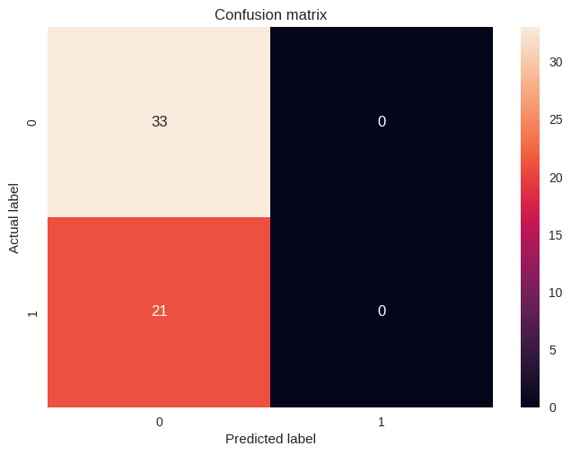
target_names = ['Presence', 'Absence']
print(classification_report(y_test, y_pred, target_names=target_names))
precision recall f1-score support
Presence 0.61 1.00 0.76 33
Absence 0.00 0.00 0.00 21
accuracy 0.61 54
macro avg 0.31 0.50 0.38 54
weighted avg 0.37 0.61 0.46 54
/usr/local/lib/python3.10/dist-packages/sklearn/metrics/_classification.py:1344: UndefinedMetricWarning: Precision and F-score are ill-defined and being set to 0.0 in labels with no predicted samples. Use `zero_division` parameter to control this behavior.
_warn_prf(average, modifier, msg_start, len(result))
/usr/local/lib/python3.10/dist-packages/sklearn/metrics/_classification.py:1344: UndefinedMetricWarning: Precision and F-score are ill-defined and being set to 0.0 in labels with no predicted samples. Use `zero_division` parameter to control this behavior.
_warn_prf(average, modifier, msg_start, len(result))
/usr/local/lib/python3.10/dist-packages/sklearn/metrics/_classification.py:1344: UndefinedMetricWarning: Precision and F-score are ill-defined and being set to 0.0 in labels with no predicted samples. Use `zero_division` parameter to control this behavior.
_warn_prf(average, modifier, msg_start, len(result))

